**Buche, S011, F1, M1, AII**

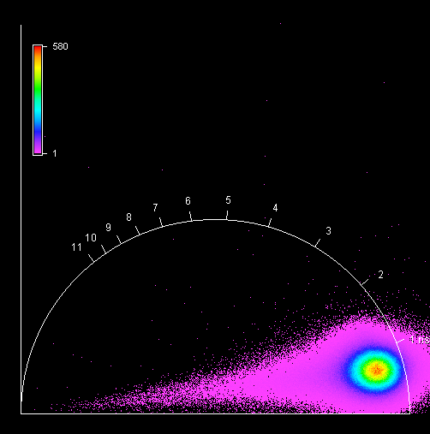

**Buche, S011, F1, M2, AII**

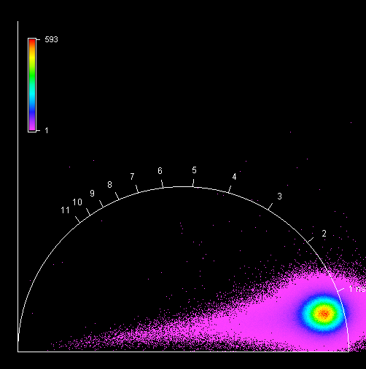

**Buche, S011, F1, M3, AII**

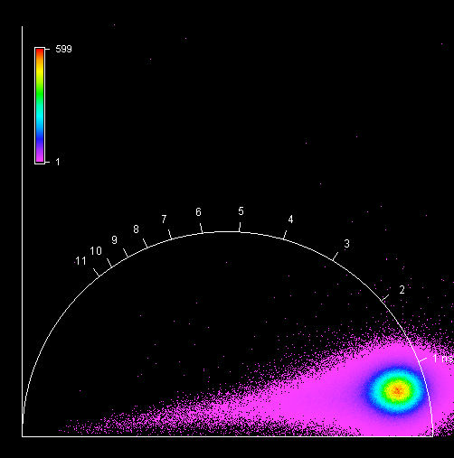

**Buche, S011, F1, M4, AII**

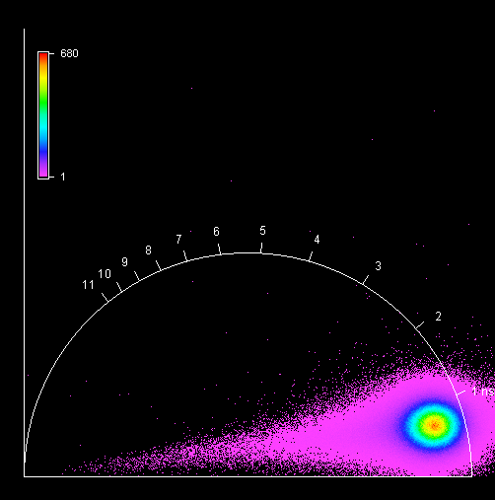

**Buche, S012, F1, M1, AI**

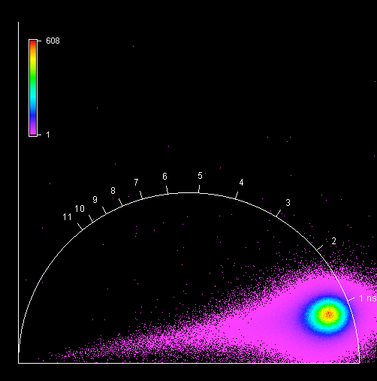

**Buche, S012, F1, M2, AI**

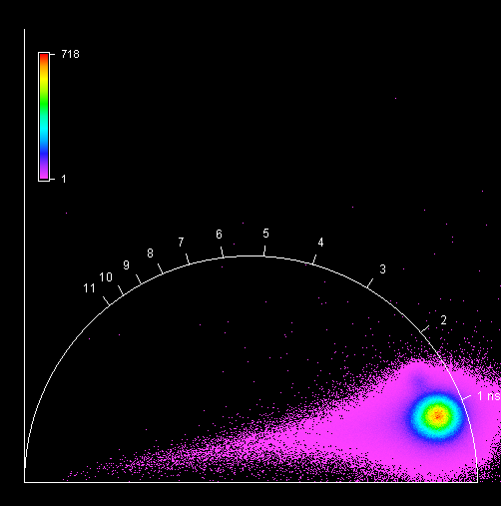

**Buche, S012, F1, M3, AI**

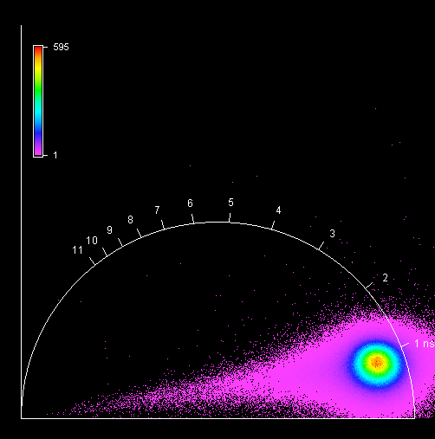

**Buche, S012, F1, M4, AI**

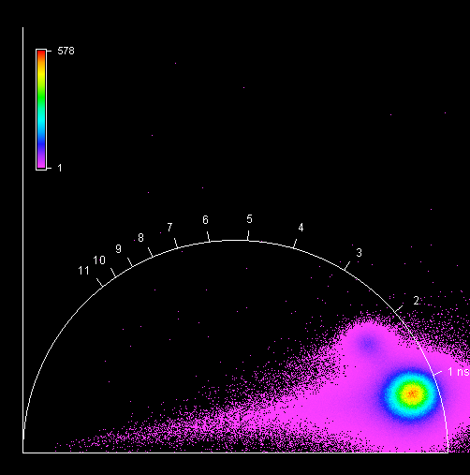

**Fichte, S013, F1, M1, AI**

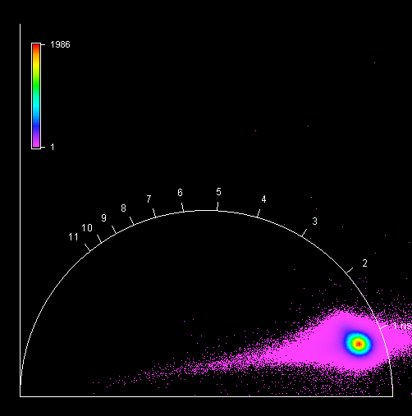

**Fichte, S013, F1, M2, AI**

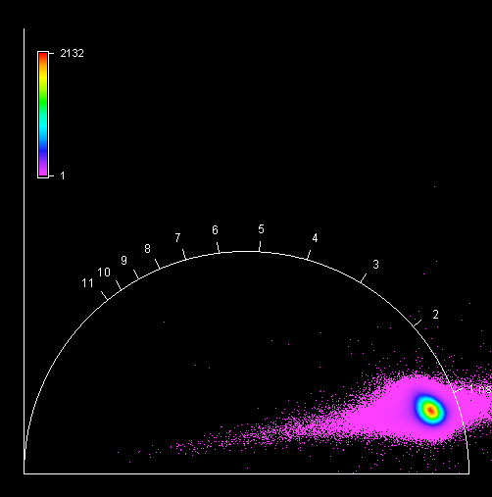

**Fichte, S013, F1, M3, AI**

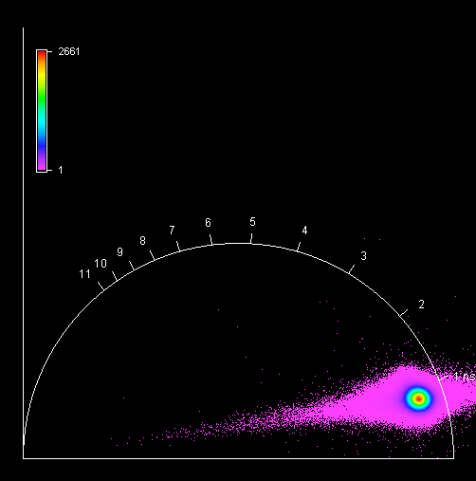

**Fichte, S013, F1, M4, AI**

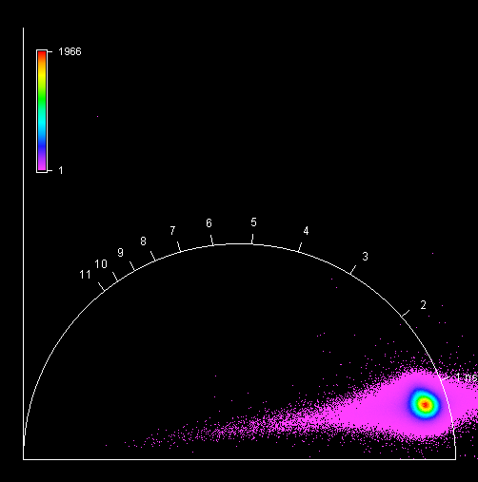

**unknown, S014, F1, M1, AIII**

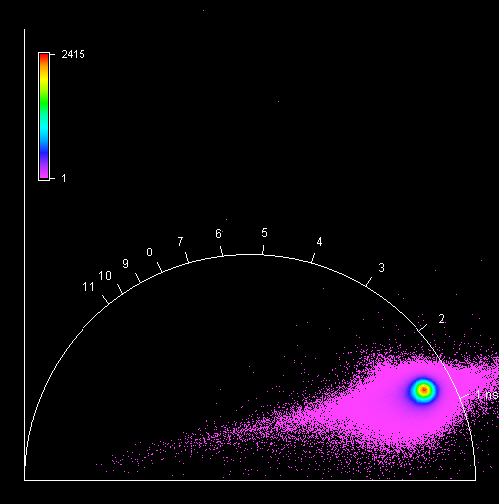

**unknown, S014, F1, M2, AIII**

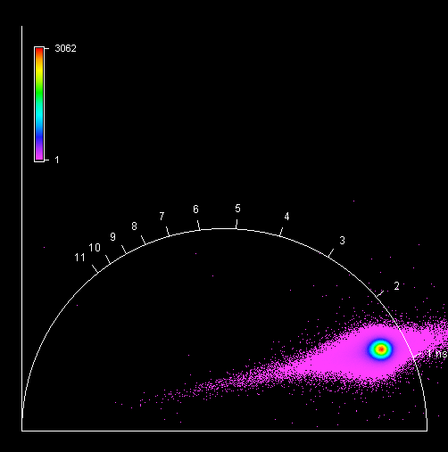

**unknown, S014, F1, M3, AIII**

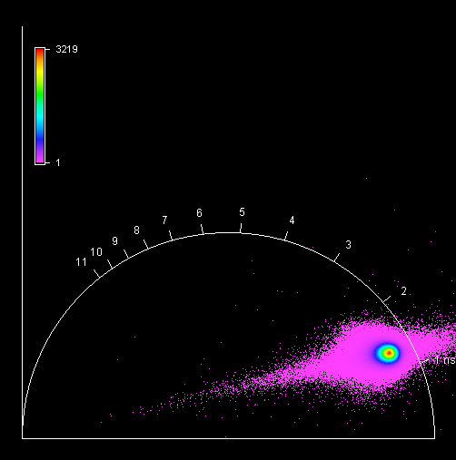

**unknown, S014, F1, M4, AIII**

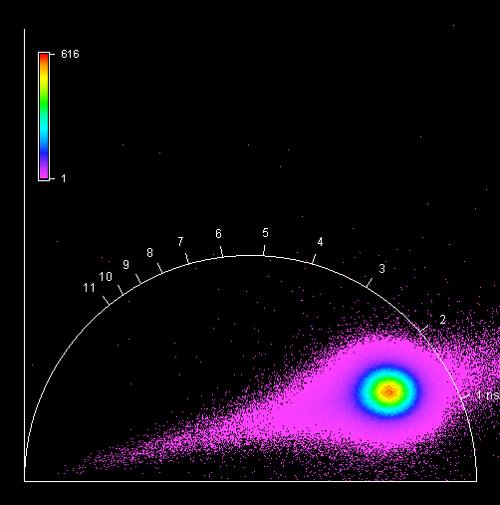

**Fichte, S015, F1, M1, AI**

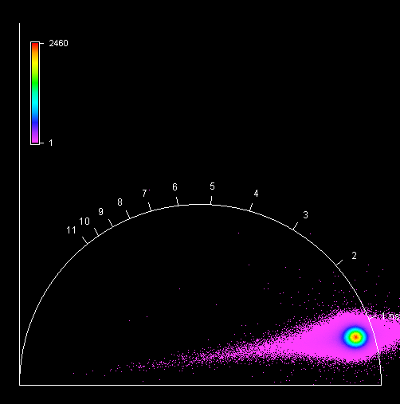

**Fichte, S015, F1, M2, AI**

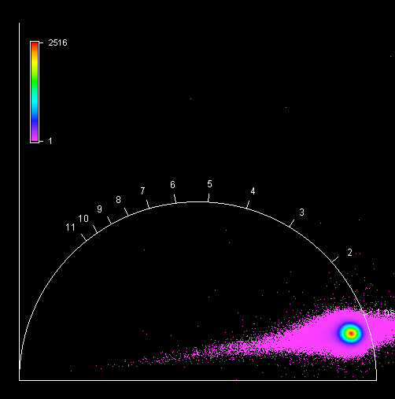

**Fichte, S015, F1, M3, AI**

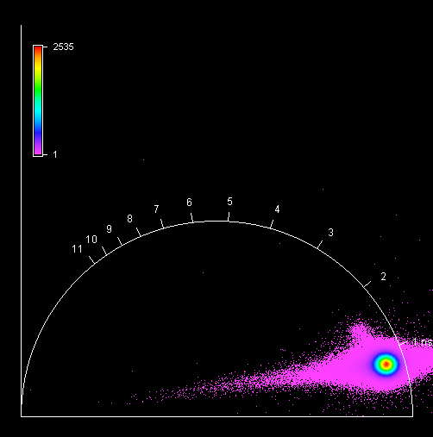

**Fichte, S015, F1, M4, AI**

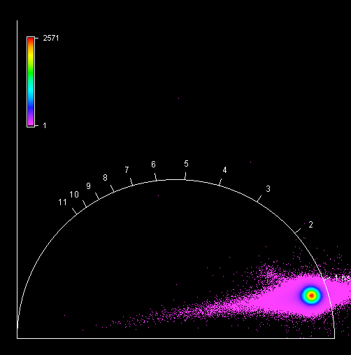

**Fichte, S015, F2, M1, AI**

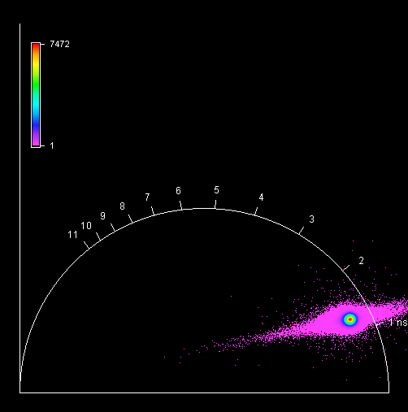

**Fichte, S015, F2, M2, AI**

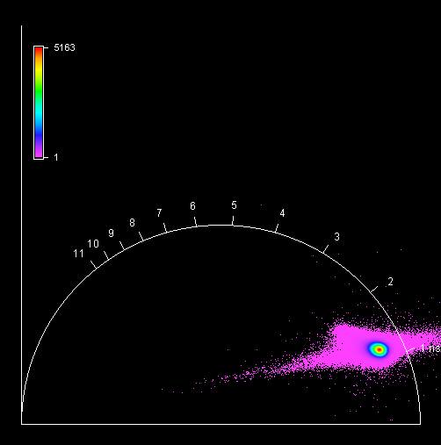

**Fichte, S015, F2, M3, AI**

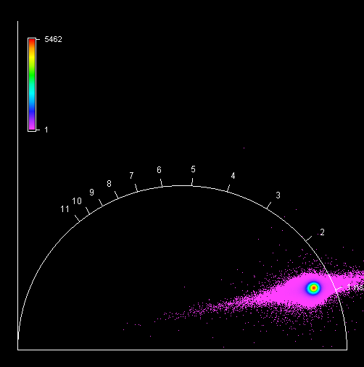

**Fichte, S015, F2, M4, AI**

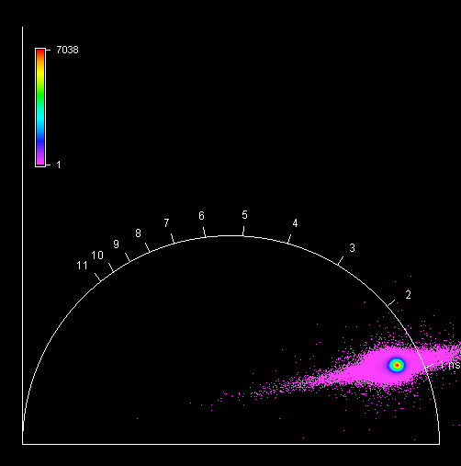

**Ahorn , S016, F1, M1, AIII**

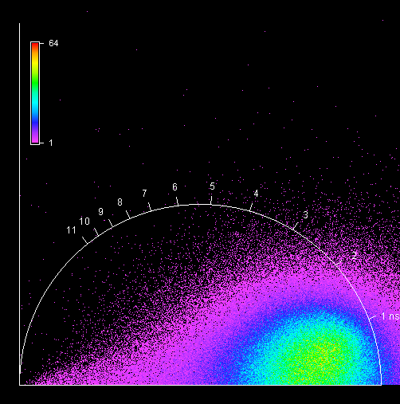

**Ahorn , S016, F1, M2, AIII**

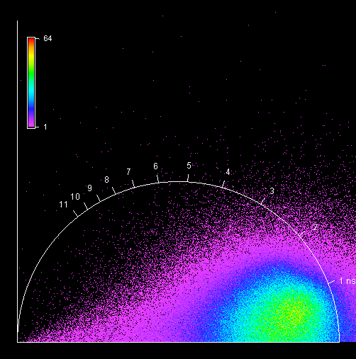

**Ahorn , S016, F1, M3, AIII**

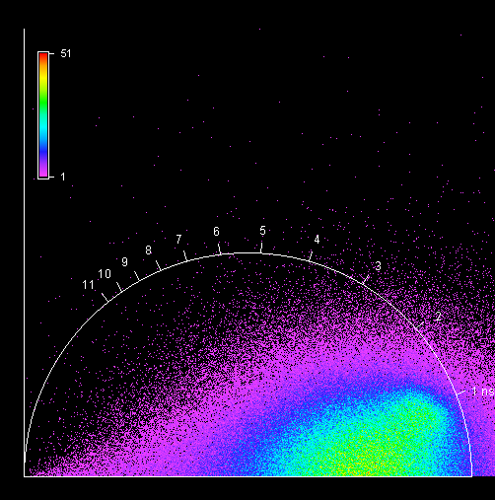

**Ahorn , S016, F1, M4, AIII**

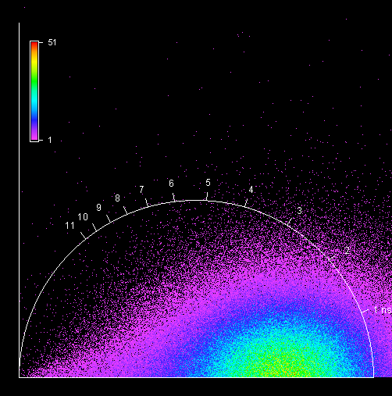

**Ahorn , S016, F2, M1, AIII**

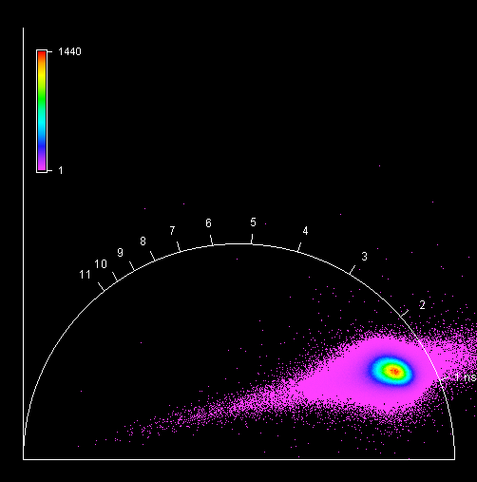

**Ahorn , S016, F2, M2, AIII**

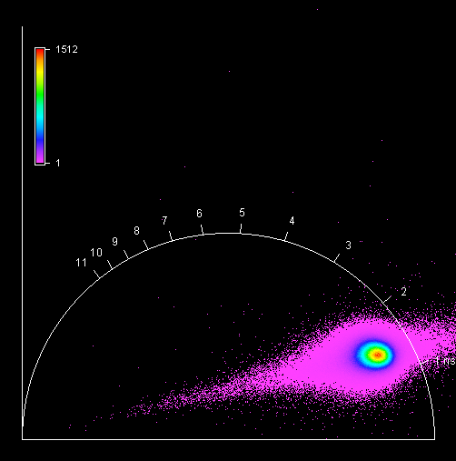

**Ahorn , S016, F2, M3, AIII**

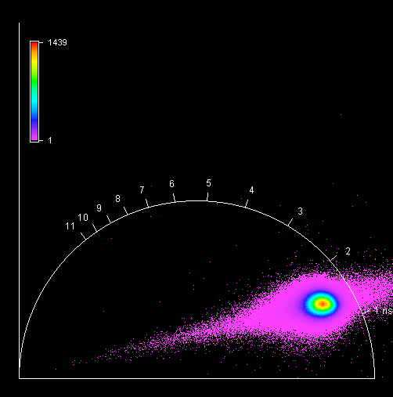

**Ahorn , S016, F2, M4, AIII**

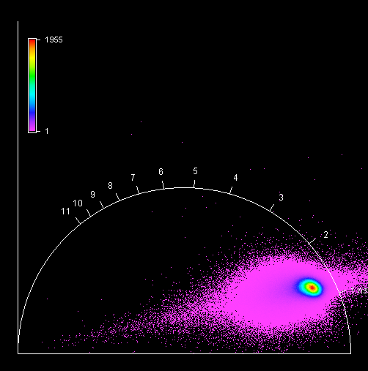

**Buche, S017, F1, M1, AI**

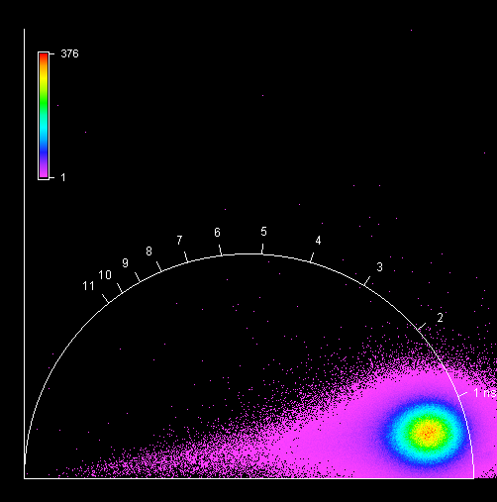

**Buche, S017, F1, M2, AI**

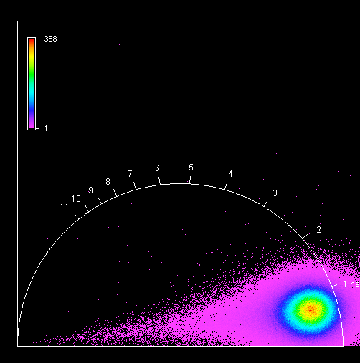

**Buche, S017, F1, M3, AI**

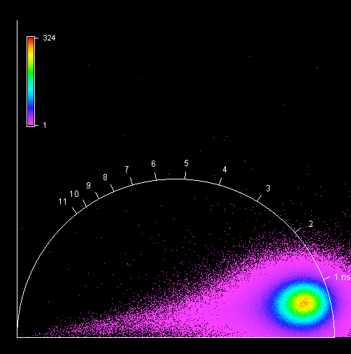

**Buche, S017, F1, M4, AI**

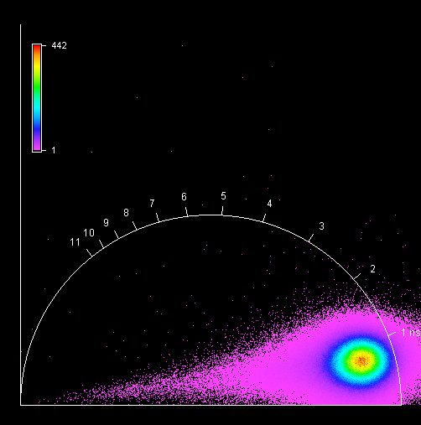

**Fichte, S018, F1, M1, AIII**

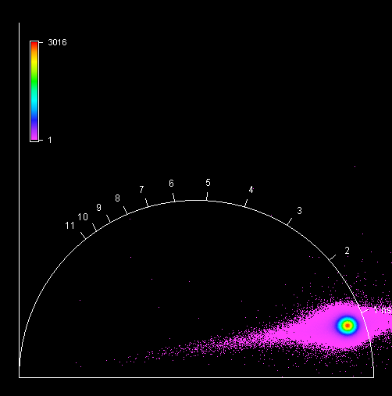

**Fichte, S018, F1, M2, AIII**

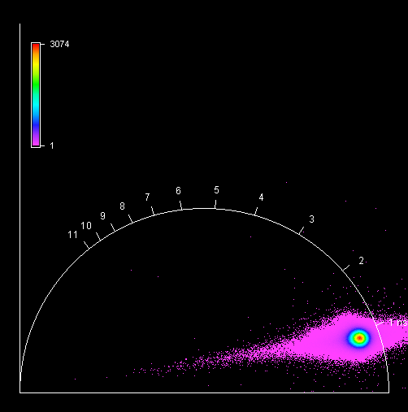

**Fichte, S018, F1, M3, AIII**

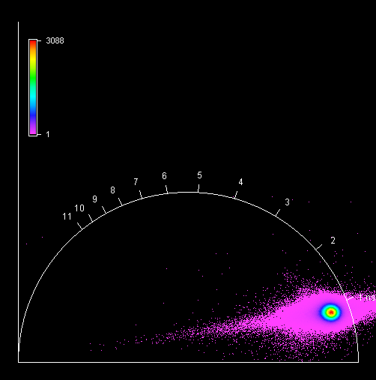

**Fichte, S018, F1, M4, AIII**

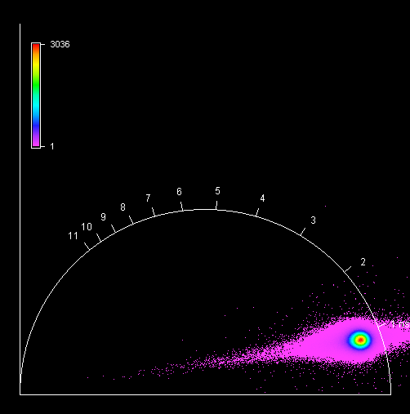

**Unknown, S019, F1, M1, AIV**

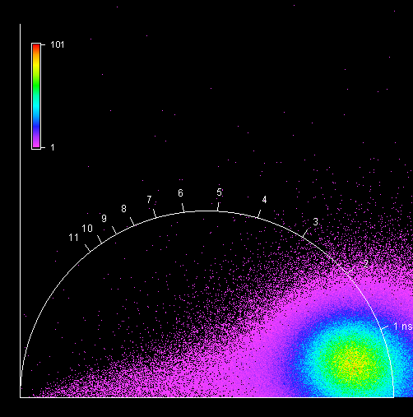

**Unknown, S019, F1, M2, AIV**

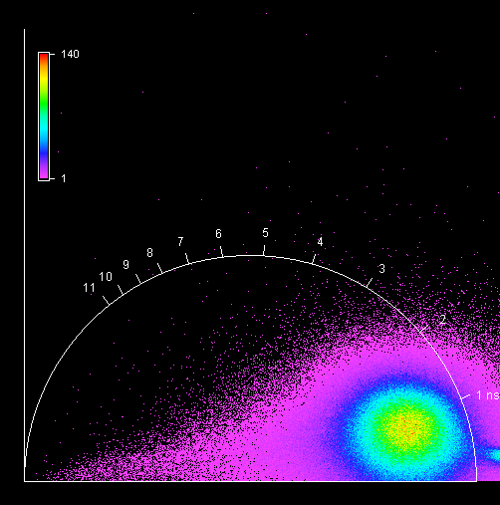

**Unknown, S019, F1, M3, AIV**

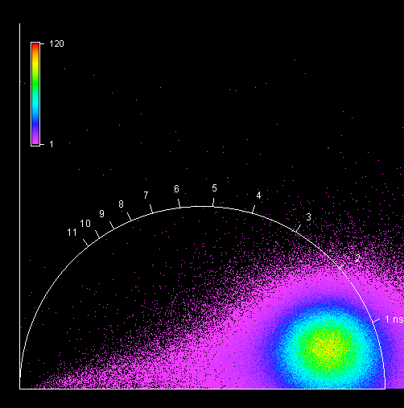

**Unknown, S019, F1, M4, AIV** 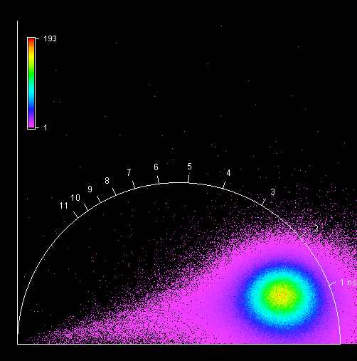

**Unknown, S019, F2, M1, AIV** 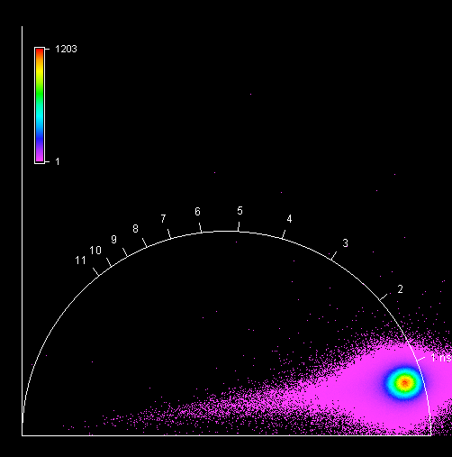

**Unknown, S019, F2, M2, AIV**

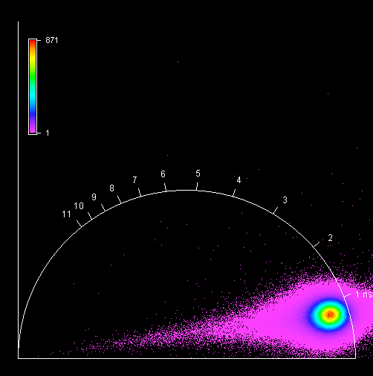

**Unknown, S019, F2, M3, AIV**

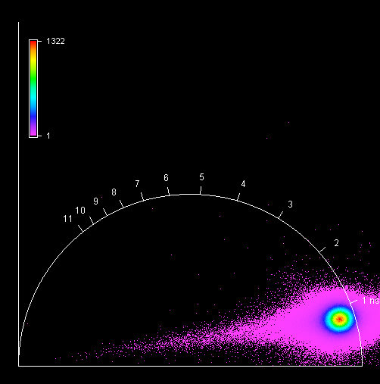

**Unknown, S019, F2, M4, AIV**

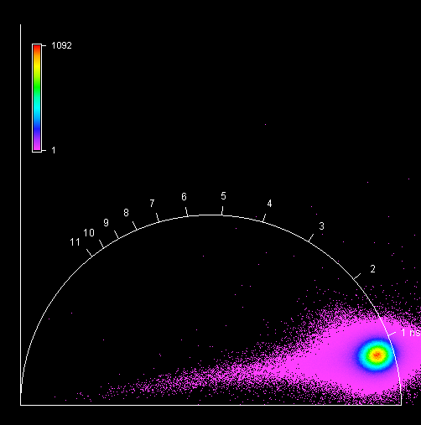

**Unknown, S020, F1, M1, AI**

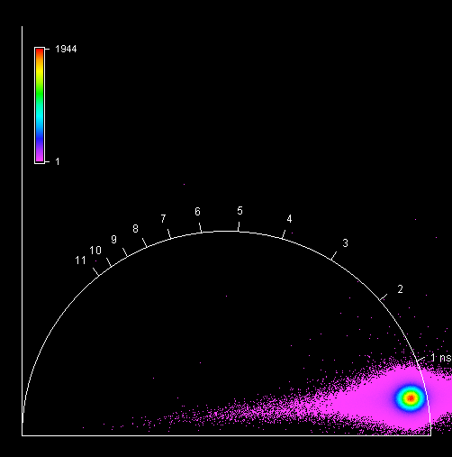

**Unknown, S020, F1, M2, AI**

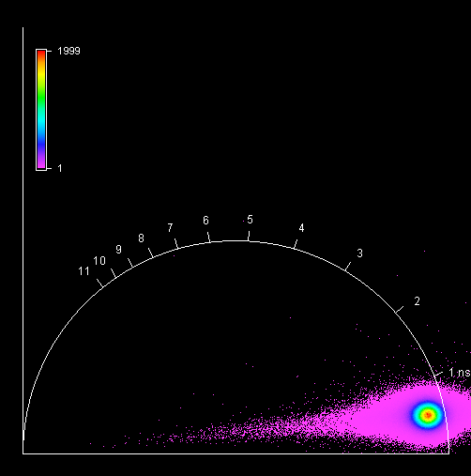

**Unknown, S020, F1, M3, AI**

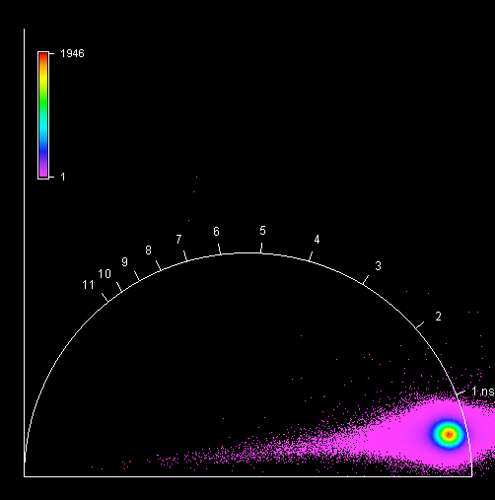

**Unknown, S020, F1, M4, AI**

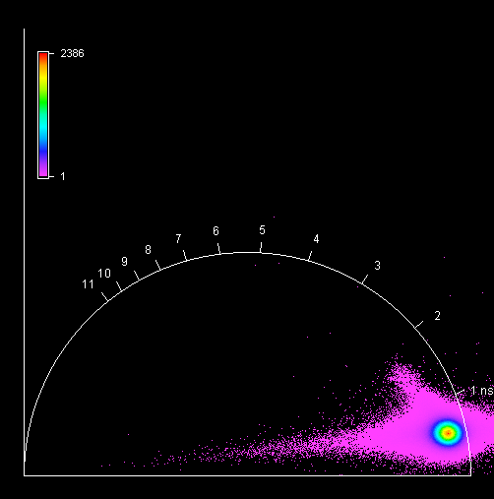

**Unknown, S021, F1, M1, AIII**

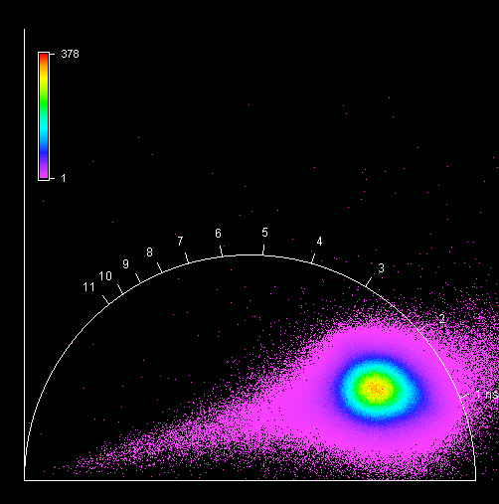

**Unknown, S021, F1, M2, AIII**

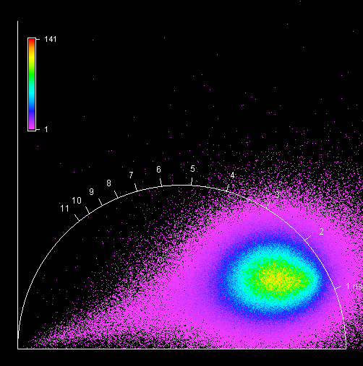

**Unknown, S021, F1, M3, AIII**

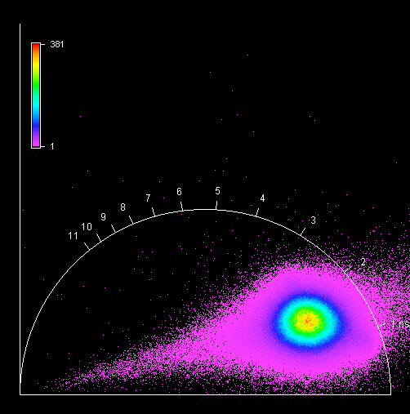

**Unknown, S021, F1, M4, AIII**

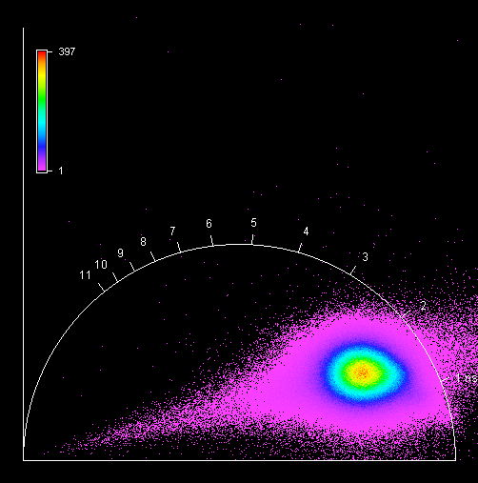

**Unknown, S022, F1, M1, AII**

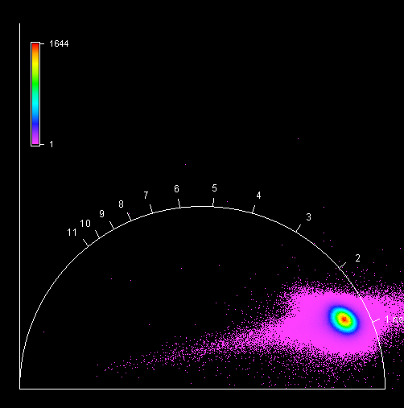

**Unknown, S022, F1, M2, AII**

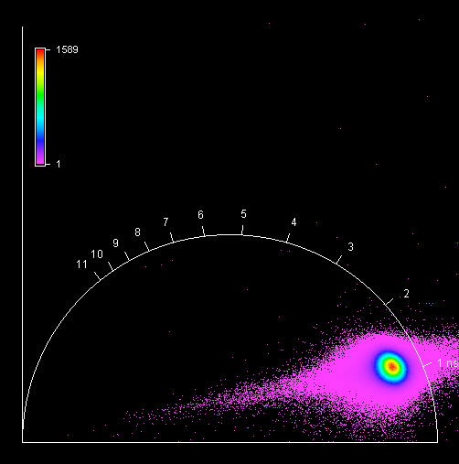

**Unknown, S022, F1, M3, AII**

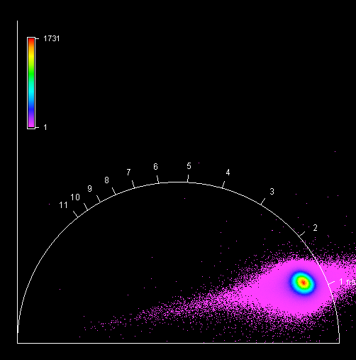

**Unknown, S022, F1, M4, AII**

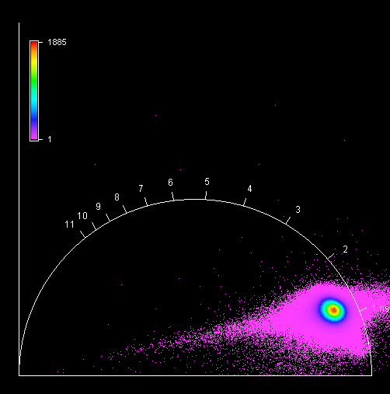

**Unknown, S023, F1, M1, AII**

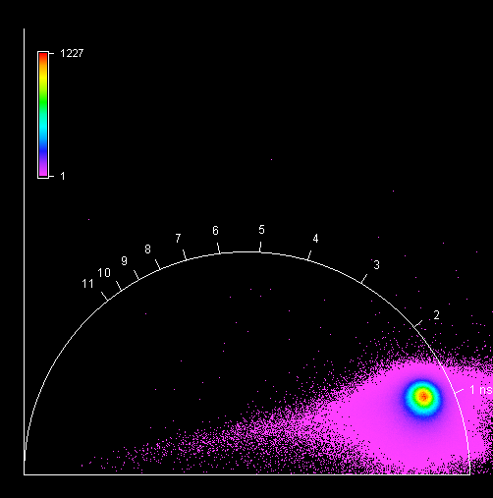

**Unknown, S023, F1, M2, AII**

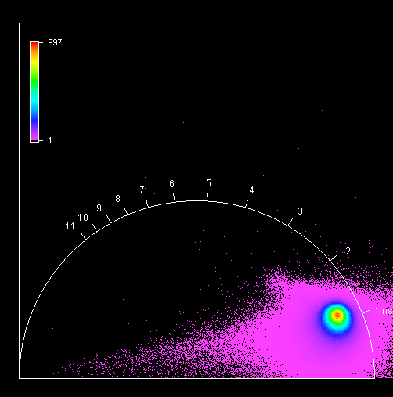

**Unknown, S023, F1, M3, AII**

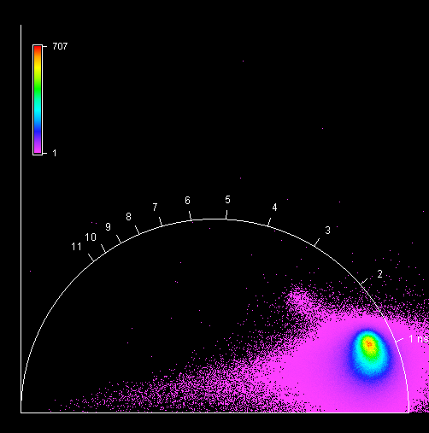

**Unknown, S023, F1, M4, AII**

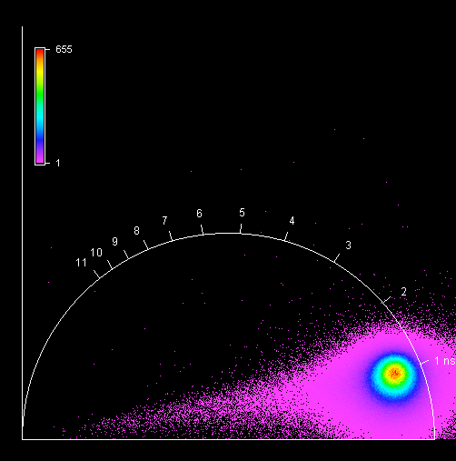

**Unknown, S024, F1, M1, AIII**

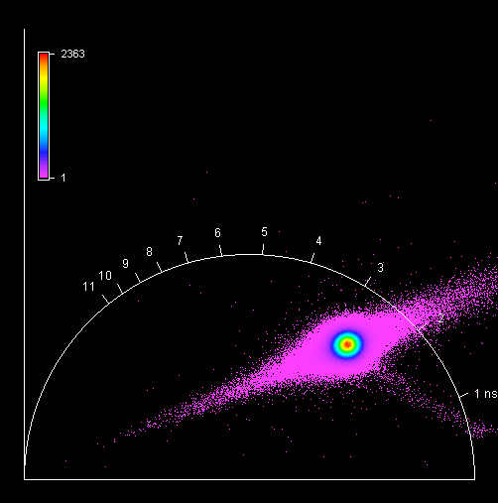

**Unknown, S024, F1, M2, AIII**

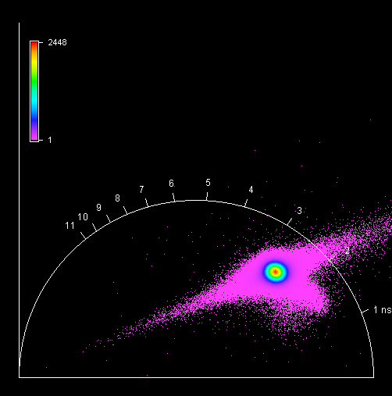

**Unknown, S024, F1, M3, AIII**

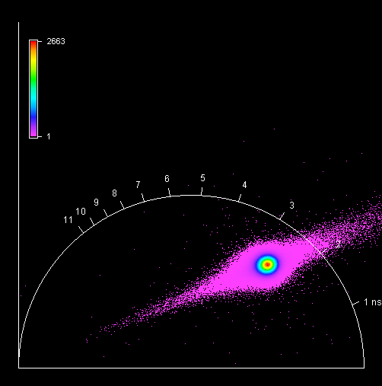

**Unknown, S024, F1, M4, AIII**

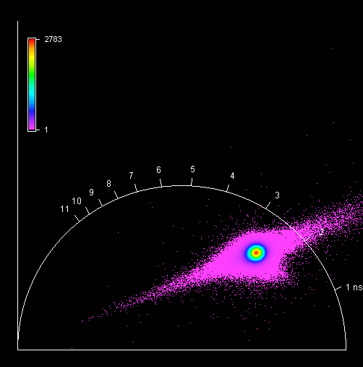

**Unknown, S024, F2, M1, AIII**

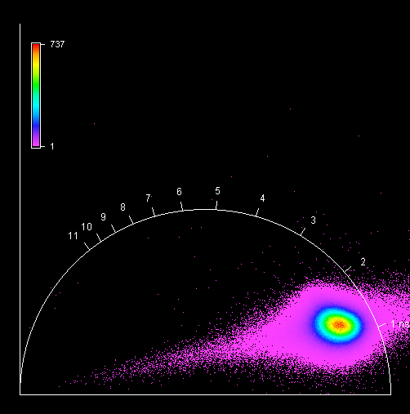

**Unknown, S024, F2, M2, AIII**

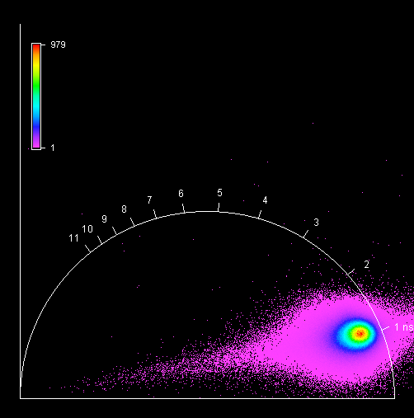

**Unknown, S024, F2, M3, AIII**

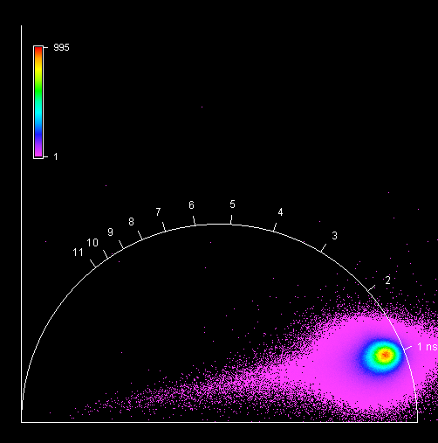

**Unknown, S024, F2, M4, AIII**

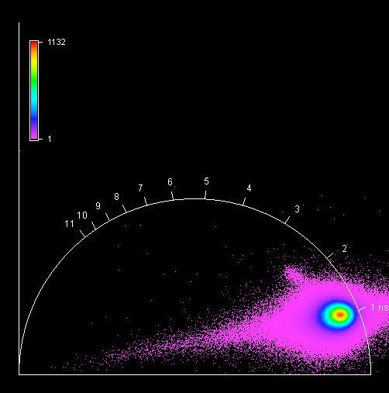

**Unknown, S025, F1, M1, AI**

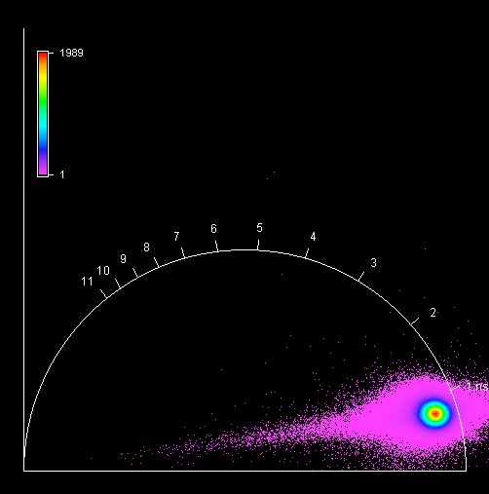

**Unknown, S025, F1, M2, AI** 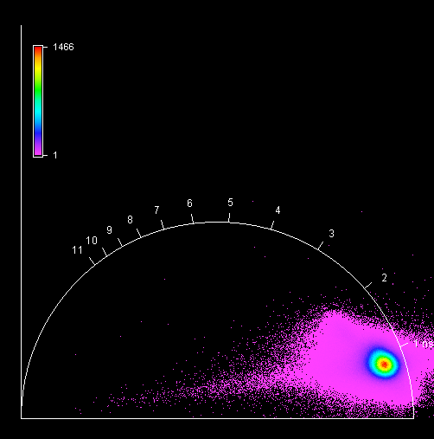

**Unknown, S025, F1, M3, AI**

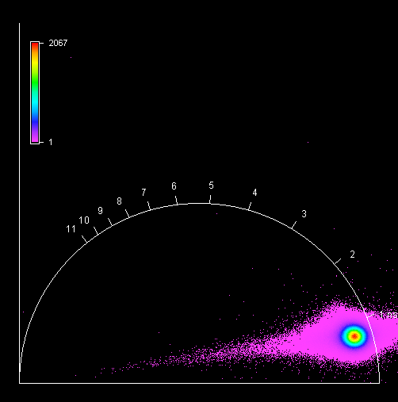

**Unknown, S025, F1, M4, AI**

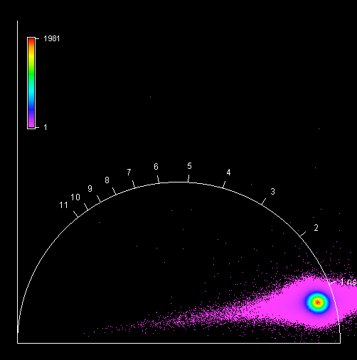

**Unknown, S026, F1, M1, AIII**

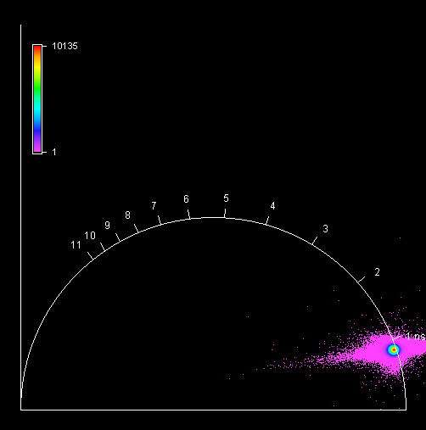

**Unknown, S026, F1, M2, AIII**

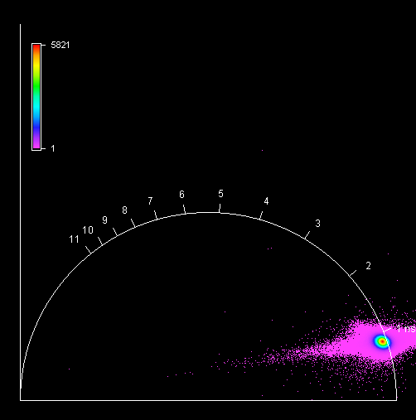

**Unknown, S026, F1, M3, AIII**

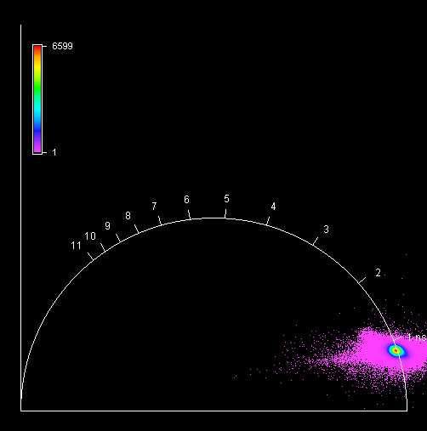

**Unknown, S026, F1, M4, AIII**

